**Maximizing Sales Through Strategic Product Bundling**

**Final Report BDM capstone Project**

Submitted by

Name:Kavya Dwivedi

Roll number: XXXXXXXXXX



IITM Online BS Degree Program,

Indian Institute of Technology, Madras, Chennai

Tamil Nadu, India, 600036

**Contents**

1 Executive Summary and Title (200 Words) **2**

2 Detailed Explanation of Analysis Process/Method **2-5**

3 Results and Findings**6-16**

4 Interpretation of Results and Recommendation **16-19**

# Executive Summary and Title (200 Words)

In my pursuit of enhancing sales and profitability for The XXXXXX Company, I embarked on a data-driven journey, focusing on optimizing product performance and refining customer segmentation. Leveraging advanced analytical techniques including Pareto Analysis, ABC Analysis, and RFM metrics, profound insights emerged. Majority of the time was consumed in the data cleaning and organizing process as the data provided wasn’t structured and was not organized well.

Key discoveries unveiled the significant impact of SKU's M41, M101, M225, and M285 on the company's revenue, leading to the identification of innovative bundling strategies to diversify sales further.

Through customer segmentation, I identified high-value buyers like Akash Provision Store and Ayush Agencies, gaining insights into their buying patterns and enabling tailored marketing approaches.

My strategic recommendations emphasize prioritizing top-performing products for targeted promotions, implementing effective bundling strategies for cross-selling opportunities, and launching personalized marketing campaigns to engage high-value customers and enhance brand loyalty.

These data-driven strategies are poised to drive accelerated sales growth, profitability, and a sustained competitive advantage for The Mahesh Company in the market landscape.

# Detailed Explanation of Analysis Process/Method

The analysis process for The XXXXXX Company's sales data involved several key steps, from data cleaning and organization to advanced analytical methods for gaining insights into product performance and customer segmentation.

1. Data Cleaning and Organization:

The process of data cleaning and organization played a pivotal role in transforming The Company's disorganized sales data into a structured and actionable resource.

During the data cleaning phase, meticulous attention was given to identifying and rectifying various issues that could compromise the data's accuracy and reliability. This included addressing missing values by either filling them in with appropriate data or removing incomplete records altogether. Duplicates were eliminated to ensure each data point was unique, preventing skewing of analytical results. Inconsistencies in data formats, such as different date representations or varying product naming conventions, were standardized for uniformity across the dataset.

Once the data was cleaned, it was organized into distinct tables tailored to different aspects of analysis. The Sales Data table encompassed comprehensive information about each sale, including transaction dates, product SKUs, quantities sold, and revenue generated. Buyer Data provided insights into customer behavior, such as purchase frequency, monetary value, and recency of purchases. Product Sales Data focused on individual product performance metrics, while Product Revenue Data aggregated revenue figures to track overall profitability trends.

This structured approach to data organization not only enhanced data accessibility but also laid the foundation for in-depth analysis and strategic decision-making. It enabled me to extract meaningful insights, identify patterns, and derive actionable recommendations aimed at driving sales growth and optimizing business performance.

1. Visualization and Basic Insights:

The utilization of visualization tools such as Google Sheets and Google Colab was instrumental in transforming the cleaned data into actionable insights. Through the creation of graphs and charts, essential patterns and trends were uncovered. This included identifying the least and most selling products, highlighting profitable buyers, and gaining a comprehensive overview of overall sales trends. Visual representations provided a clear and intuitive understanding of the data, allowing for quick identification of key performance indicators. These insights served as a foundation for further analysis and strategic decision-making, guiding the company towards effective measures to enhance sales and profitability.

1. Pareto Analysis:

Pareto Analysis, rooted in the Pareto Principle, is a valuable tool that aids in prioritizing efforts and resources by focusing on the vital few factors that contribute the most significant impact. The Pareto Principle, also known as the 80/20 rule, posits that roughly 80% of effects come from 20% of causes. In the context of business, this principle suggests that a minority of factors often contribute to the majority of outcomes or results.

In the analysis of theCompany's sales data using Pareto Analysis, several key insights were uncovered. The application of Pareto Analysis revealed that a specific subset of products contributed significantly to the company's sales revenue. The top 20% of products, identified through this analysis, accounted for approximately 80% of the total revenue generated by the company.

Furthermore, within this subset of top-performing products, four SKUs—M41, M101, M225, and M285—stood out as the most crucial contributors, collectively accounting for 50% of the total profit generated by the top 20% products. This finding highlighted the critical importance of these specific products in driving revenue and profitability for the company.

By focusing on these insights derived from Pareto Analysis, the company could strategically prioritize its efforts and resources towards maximizing the sales and profitability of these key products. This approach enables the company to make informed decisions regarding inventory management, marketing strategies, and product development initiatives, ultimately leading to improved overall performance and competitive advantage.

1. ABC Analysis:

ABC Analysis is a strategic inventory management technique that categorizes products into three groups based on their contribution to overall sales revenue. The categories are labeled as A, B, and C, with A representing the most valuable and impactful products, and C representing the least.

In this project, in sales data analysis, ABC Analysis was instrumental in identifying and prioritizing products based on their revenue contributions. Products were classified into the A, B, or C categories depending on their ABC coefficient, which is calculated by dividing the total sales of a product by the sum of total sales of all products. This coefficient serves as a measure of a product's relative importance in terms of revenue generation.

The analysis resulted in 15 products categorized as A, indicating high-impact products that contribute significantly to sales revenue. These products were strategically vital for the company's focus and resource allocation. Additionally, 35 products fell into the B category, and 28 products were categorized as C, providing a comprehensive view of the product portfolio's performance and highlighting areas for improvement or optimization.

1. Bundling Strategies:

Bundling Strategies involve combining products from different categories to create attractive packages for customers. In Mahesh Company's case, leveraging insights from Pareto and ABC analyses, bundling aimed to capitalize on the strengths of high-demand products while promoting lesser-selling ones.

By bundling products from the A (high-demand) and C (lower-demand) categories, the Company could diversify its sales offerings and appeal to a broader customer base with varied preferences. This strategy will not only maximize the sales potential of popular products but also boost the visibility and sales of less-popular items.

Bundling is a strategic marketing approach that enhances product value perception, encourages upselling, and increases customer satisfaction. In our case, bundling was used as a tactical approach to optimize product sales and cater to different customer segments effectively.

1. Customer Segmentation using RFM:

RFM (Recency, Frequency, Monetary Value) analysis is a powerful method for customer segmentation based on their purchasing behavior. In XXXXXX Company's case, RFM analysis was employed to categorize buyers into different segments, focusing on their recency of purchases, order frequency, and total monetary value.

Recency refers to how recently a customer made a purchase, indicating their engagement level. Frequency measures how often a customer makes purchases, highlighting their loyalty and engagement. Monetary value assesses the total sales generated by each customer, indicating their overall contribution to revenue.

By analyzing RFM scores, XXXXXXCompany identified high-value buyers who exhibited frequent purchases, high monetary value, and recent activity. This segmentation allowed the company to tailor marketing strategies, loyalty programs, and personalized offers to different customer segments effectively. It also helped in understanding customer behavior patterns, optimizing customer retention efforts, and maximizing revenue generation.

1. Strategic Insights and Recommendations:

The strategic insights and recommendations derived from the analysis process for the company encompassed a data-driven approach to optimize various aspects of their business operations. This approach involved leveraging insights from Pareto Analysis, ABC Analysis, bundling strategies, and RFM customer segmentation to drive actionable recommendations.

Prioritizing Top-Performing Products: By identifying the top-performing products through Pareto Analysis, the company could focus its resources on promoting these products more effectively. This included targeted promotions, pricing strategies, and inventory management to capitalize on high-demand items.

Implementing Effective Bundling Strategies: Bundling strategies were recommended based on ABC Analysis, combining high-demand products with lesser-selling ones to increase sales diversity. This approach aimed to boost sales of low-demand products by associating them with more popular items in customer bundles.

Tailoring Marketing Campaigns: Customer segmentation using RFM analysis can allow personalized marketing campaigns targeting high-value customers. These campaigns could include loyalty programs, special offers, and tailored communications to enhance customer engagement and retention.

Overall, these strategic insights and recommendations were designed to optimize sales performance, improve customer segmentation, and drive sustainable growth and profitability for The Mahesh Company.

# Results and Findings

1. Pareto Principle:

The Pareto Principle, also known as the 80/20 rule, was applied to analyze sales data for The Mahesh Company. The results and findings of this analysis provided crucial insights into the company's revenue generation and product performance:

Identification of Top-Performing Products: The Pareto Analysis revealed that a small proportion of products, specifically nineteen SKU numbers which include M41, M101, M225, M285,M321 and M283 accounted for a significant portion of the company's sales revenue. These products constituted the top 20% that contributed approximately 80% of the total sales revenue during the April to June term.

Revenue Contribution: Among these top-performing products, SKU numbers M41, M101, M225, and M285 stood out by collectively generating 50% of the total profit for the company which was around 1.5 lakh rupees during the specified period. This highlighted the critical role these products played in driving profitability and indicated their importance in the company's product portfolio.

Strategic Focus Areas: By identifying the products that contributed the most to sales revenue, the Pareto Principle enabled strategic decision-making. The company could prioritize resources, marketing efforts, and operational strategies towards these high-impact products. This focus will allow targeted promotions, inventory management optimization, and product development initiatives aiming at maximizing revenue from key products.

Optimized Resource Allocation: Understanding the Pareto principle helped in resource management. By concentrating efforts on the top-performing products, the company could streamline operations, reduce costs associated with low-performing products, and improve overall profitability.

Future Growth Strategies: Armed with insights from the Pareto Analysis, The Mahesh Company could devise future growth strategies. This included expanding product lines or enhancing marketing strategies for the top-performing products while also addressing opportunities to improve the performance of other products through targeted interventions.

In summary, the Pareto Principle analysis provided actionable insights that guided strategic decision-making, resource allocation, and growth strategies for The Mahesh Company. It emphasized the significance of focusing on key products to drive revenue and profitability effectively.

These graphs will visually represent the insights derived from pareto principle :

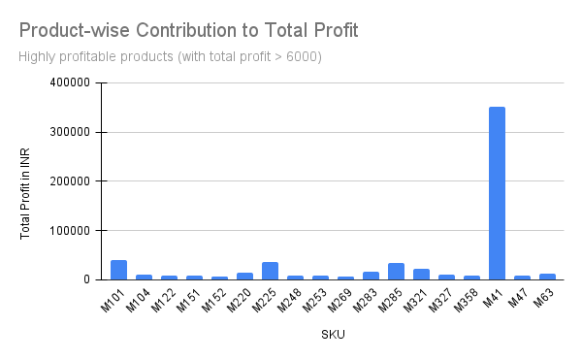

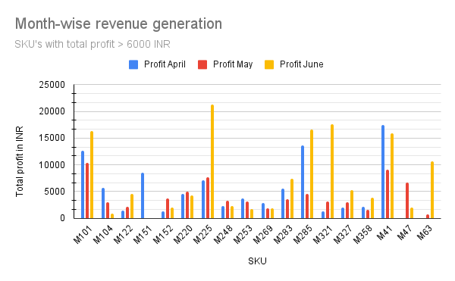

1. ABC Analysis: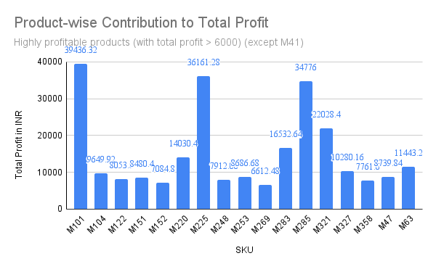

ABC Analysis involved categorizing products into three bins (A, B, and C) based on their contribution to sales revenue. The calculation of the ABC coefficient was crucial in determining the classification of products.

Application of ABC Analysis:

Calculation of ABC Coefficient: The ABC coefficient was calculated by dividing the total sales of each product SKU by the sum of total sales of all products. This coefficient provided a relative measure of each product's contribution to overall sales revenue.

Classification into A, B, and C Categories: Based on their ABC coefficients, products were categorized into A, B, or C categories. A-category products had the highest contribution to sales revenue with ABC Coefficient >0.02 , followed by B-category products, with coefficient between 0.02 and 0.002 and then C-category products with coefficient less than 0.002.

Results and Findings:

A-Category Products: These products accounted for a significant portion of total sales revenue, indicating their high importance in revenue generation. They typically comprised a smaller number of SKUs but contributed substantially to the company's revenue.

B-Category Products: Products in this category had a moderate contribution to sales revenue. They were important but not as critical as A-category products in terms of revenue generation.

C-Category Products: These products had the lowest contribution to sales revenue. While they were still part of the product portfolio, their individual impact on overall revenue was comparatively lower.

Strategic Insights:

Resource Allocation: The categorization allowed for strategic resource allocation, with a focus on A-category products that drove the majority of revenue.

Inventory Management: It facilitated inventory management by prioritizing high-impact products and ensuring adequate stock levels for them.

Marketing Strategies: Different marketing strategies could be devised for each category, such as promoting A-category products more aggressively while implementing targeted campaigns to boost sales of B and C-category products.

By applying ABC Analysis, the company gained valuable insights into its product portfolio's revenue contribution hierarchy. This knowledge empowered strategic decision-making regarding resource allocation, inventory management, and marketing strategies, ultimately contributing to improved profitability and performance.

Below are the graphs that add more value to what is said above.

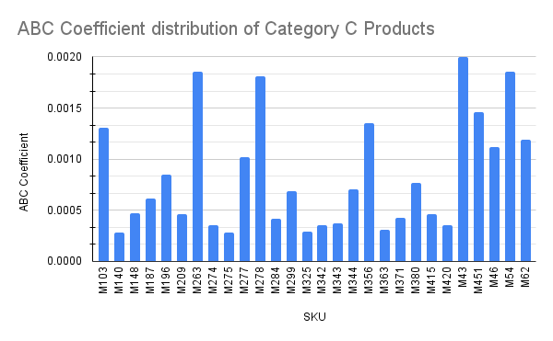

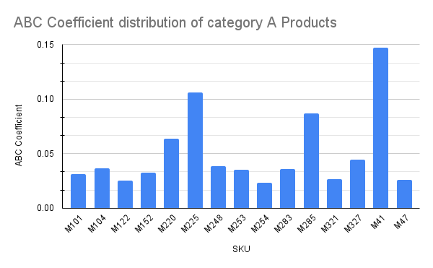

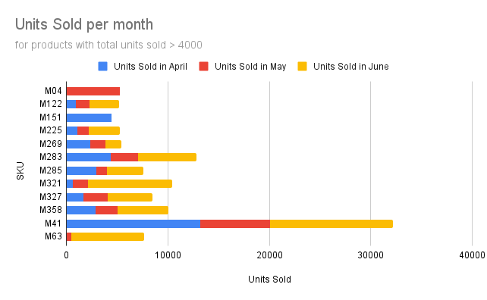

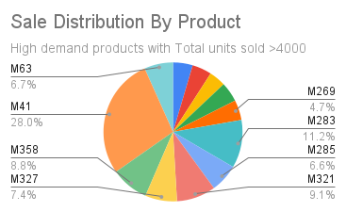

1. Recency, Frequency, Monetary Value (RFM) Analysis:

RFM (Recency, Frequency, Monetary Value) Analysis is a powerful technique used to segment customers based on their recent purchase behavior, frequency of purchases, and monetary value spent. Here's a detailed explanation of the results and findings derived from RFM Analysis, along with how it was applied in my project:

Application of RFM Analysis:

Recency: The analysis began by determining the recency of each customer's last purchase. Customers who made purchases more recently were given higher recency scores.

Frequency: The frequency component measured how often customers made purchases. It considered both the number of orders placed and the months in which purchases were made.

Monetary Value: The monetary value aspect calculated the total sales made to each customer during the specified period.

Results and Findings:

High-Value Customers: RFM Analysis identified high-value customers based on their RFM scores. These customers exhibited characteristics such as frequent purchases, recent activity, and significant monetary contributions.

Segmentation: Customers were segmented into different categories based on their RFM scores. For example, customers with high recency, frequency, and monetary value were categorized as premium or VIP customers, while those with lower scores fell into different segments based on their behavior.

Insights into Customer Behavior: The analysis provided insights into customer behavior patterns. For instance, it revealed which customers were loyal and made consistent purchases, as well as those who may need incentives to increase their purchase frequency or monetary value.

Targeted Strategies: RFM Analysis enabled the development of targeted marketing and retention strategies. High-value customers could receive exclusive offers or rewards to maintain their loyalty, while lower-value segments could be targeted with promotions to boost their engagement and spending.

Application in my Project:

In my project, RFM Analysis was instrumental in:

Identifying high-value customers like Akash Provision Store and Ayush Agencies, who made frequent purchases and contributed significantly to sales revenue.

Segmenting customers based on their RFM scores to tailor marketing strategies and promotions accordingly.

Providing actionable insights for customer retention, loyalty programs, and personalized marketing campaigns aimed at different customer segments.

Overall, RFM Analysis played a crucial role in understanding customer behavior, optimizing marketing efforts, and enhancing customer relationships to drive business growth and profitability.

Below are the charts that provide insights related to Buyers contribution to sales and profit of the company.

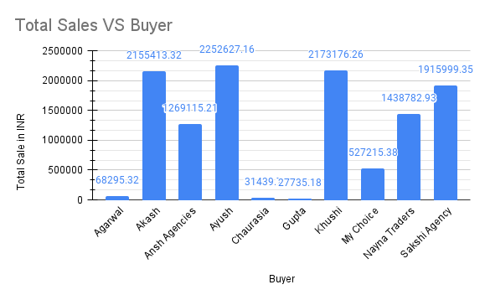

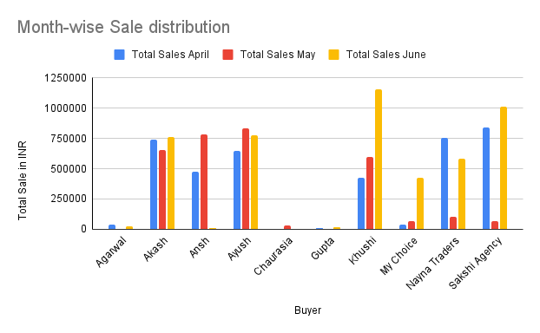

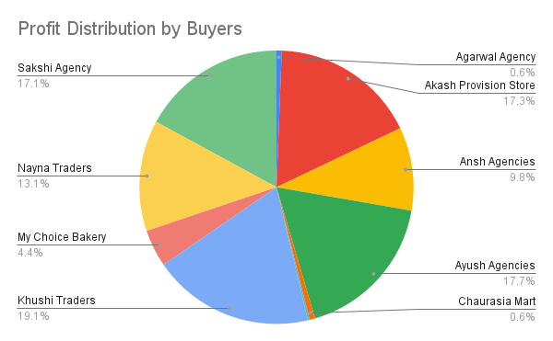

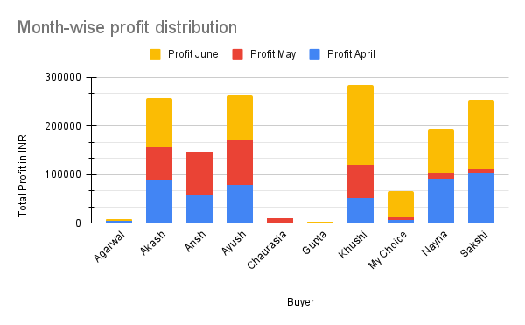

1. Product and Buyer categorisation and Product Bundling:

Product categorization and buyer segmentation are vital components of strategic decision-making in retail and sales management. In my project, these techniques were used to effectively categorize products and segment buyers, ultimately leading to the formulation of targeted bundling strategies.

Product Categorization:

ABC Analysis: Initially, ABC Analysis was applied to categorize products into three main categories based on their sales contribution: A, B, and C.

Category A: Included top-selling products contributing significantly to sales revenue.

Category B: Comprised products with moderate sales contributions.

Category C: Encompassed products with lower sales contributions.

This categorization helped prioritize products for focused marketing efforts and resource allocation.

Buyer Segmentation:

RFM Analysis: Buyer segmentation was achieved through RFM Analysis, which evaluated customers based on Recency, Frequency, and Monetary Value.

High-value buyers with frequent purchases, recent activity, and significant monetary contributions were identified.

Segmentation allowed for tailored marketing strategies and personalized approaches for different buyer segments.

Product Bundling Strategy:

Leveraging insights from product categorization and buyer segmentation, product bundling strategies were devised.

Bundling involved combining high-demand products from Category A with lesser-selling products from Category C in bundles.

The rationale behind bundling was to:

Increase sales diversity by promoting a mix of popular and less popular products.

Attract customers by offering bundled products at competitive prices, encouraging upselling and cross-selling.

Clear slow-moving inventory by bundling with faster-selling items.

Enhance customer experience by providing value-added bundles tailored to varying customer preferences.

Boost overall sales revenue and profitability by optimizing product offerings and maximizing customer value.

Benefits of Bundling:

Maximizing Product Exposure: Bundling enables lesser-selling products to gain visibility and exposure alongside popular items, increasing their chances of being noticed and purchased.

Optimizing Inventory Management: Bundling helps manage inventory effectively by pairing slow-moving products with faster-selling ones, reducing excess stock and improving turnover rates.

Driving Sales and Revenue: By offering bundled products at attractive prices, customer interest and sales are stimulated, leading to increased revenue and profitability.

Enhancing Customer Satisfaction: Bundles cater to diverse customer preferences and needs, enhancing customer satisfaction and loyalty by providing value-added offerings.

In conclusion, product categorization, buyer segmentation, and strategic product bundling were instrumental in addressing the company's sales and profit goals. These techniques not only optimized product offerings but also enhanced customer engagement and revenue generation, contributing to sustainable business growth and success.

## 

# Interpretation of Results and Recommendation

**Interpretation of Results**

A data-driven approach to identifying valuable products and implementing strategic bundling strategies reflects a deep understanding of maximizing revenue and profit margins. Applying this on the sales data of the company provided valuable insights and the results hence founds are as follows:

Sales Analysis:

The SKU "M41" emerged as the top-selling product, consistently contributing to high sales and indicating strong customer demand.

Other top-performing SKUs include "M101," "M41," and "M225," suggesting a preference for these products among customers.

Products such as "M63" and "M327" showed lower sales, indicating potential areas for improvement in marketing or product positioning.

Valuable Product Analysis:

M41 emerges as the most valuable product, contributing significantly to the company's revenue stream, accounting for 11.02% of total revenue. Its consistent demand and high-profit margin make it a key asset.

Alongside M41, M101 and M225 stand out as valuable products, despite variations in demand. M101, in particular, showcases a substantial profit contribution, indicating a strategic advantage due to its profit margin.

Products like M101, M103, and M104, while not the highest in demand, boast maximum profit margins. This underscores the importance of considering profit margins alongside demand when strategizing inventory and sales.

Customer Preferences:

There is a noticeable preference for products in the A category, with these products contributing significantly to overall sales and profits.

Customers seem to favor products with higher ABC coefficients, indicating a preference for high-impact products.

Bundling strategies combining A and C category products could help increase sales diversity and cater to different customer segments effectively.

Bundling Strategy:

The decision to bundle products strategically is well-founded, aiming to capitalize on the popularity of high-demand items like M41 while leveraging the profit potential of products like M101, M103, and M104.

Bundling these products aligns with maximizing sales diversity and profitability. It ensures that both high-demand products, low-demand products and those with high-profit margins are promoted and sold effectively.

Forming bundles of C category products with A category products of similar kind can help increase sales of both the category of products. Ensure a pricing that will not only benefit the buyer to prioritize the combo of products over single products but also maintain the profit margin of the company.

Buyer Segmentation:

Consider customer segmentation based on RFM analysis to tailor promotions and offers for high-value customers, enhancing customer retention and loyalty.

Continuously monitor sales trends and customer preferences to adapt strategies and stay competitive in the market.

By interpreting the results of the analysis, the company can make informed decisions to optimize product offerings, marketing strategies, and customer engagement, ultimately driving growth and profitability.

**Recommendations:**

1. High-Value Buyers Focus:

Identify and prioritize high-value buyers such as Khushi Traders, Akash Provision Store, Ansh Agencies, and Ayush Agencies who contribute significantly to sales revenue.

Offer personalized promotions, loyalty rewards, and exclusive deals to incentivize repeat purchases and strengthen brand loyalty.

Provide excellent customer service and timely order fulfillment to enhance the overall buying experience.

Low-Frequency Buyers Conversion:

Target low-frequency buyers like Chaurasia Mart, Gupta Provision Store, and Agarwal Agency with tailored promotions and discounts to encourage more frequent purchases.

Leverage email marketing and targeted advertisements to remind and entice infrequent buyers about ongoing promotions and new product offerings.

Engagement Strategies for New Buyers:

Use customer feedback surveys or follow-up emails to understand new buyers' preferences and tailor future promotions and product recommendations accordingly.

Leverage social media platforms and influencer collaborations to reach out to a wider audience and attract new buyers.

1. Optimize Inventory:

Maintain a robust inventory of Category A products, especially focusing on M41, M101, M103, M248, M253, M 254, M283 and M104, as they significantly contribute to revenue and profit margins. Implement efficient inventory management practices, such as regular audits, demand forecasting, and strategic ordering, to ensure optimal stock levels and meet customer demand effectively.

1. Promotional Bundles:

Implement promotional strategies that bundle high-demand items with high-profit-margin products to drive sales and profitability simultaneously.   
To drive sales and profitability concurrently, strategic promotional bundles are proposed. These bundles intelligently combine high-demand items with high-profit-margin products, aiming to maximize revenue streams. Moreover, the strategy extends to include lesser-demanded products, ensuring a comprehensive approach to boost overall sales.

Outlined below are curated bundles along with suggested prices, meticulously designed to offer buyers compelling value while optimizing business profitability:

Bundle 1:

Products: M41 (High-Demand, High-Profit) + M04(Low Demand)

Suggested Price: 21.5 INR

Bundle 2:

Products: M225 (High-Demand, High-Profit) + M103 (High-Profit and Low demand)+

Suggested Price: 461 INR

Bundle 3:

Products: M101 (High-Profit, High Demand) + M04(Low Demand)

Suggested Price: 158 INR

Bundle 4:

Products: M41 (High-Demand, High-Profit) + M103 (High-Profit, Low Demand)

Suggested Price: 410 INR

Bundle 5:

Products: M101 (High-Profit) + M103 (High-Profit,Low demand)

Suggested Price: 550 INR

To check all the bundles [click here](https://docs.google.com/spreadsheets/d/1WkeKQFIhU3UKPpLSjYpEM28tEco47NRtPoihkj90Lcs/edit?usp=sharing).

# 